# Singleton design pattern

## 

# Prototype design pattern

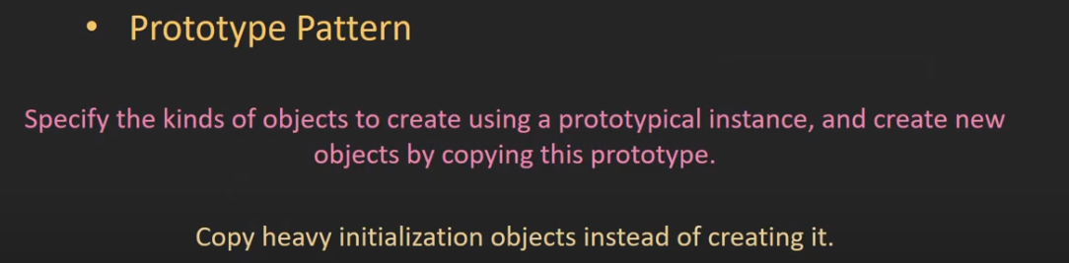

Class diagram

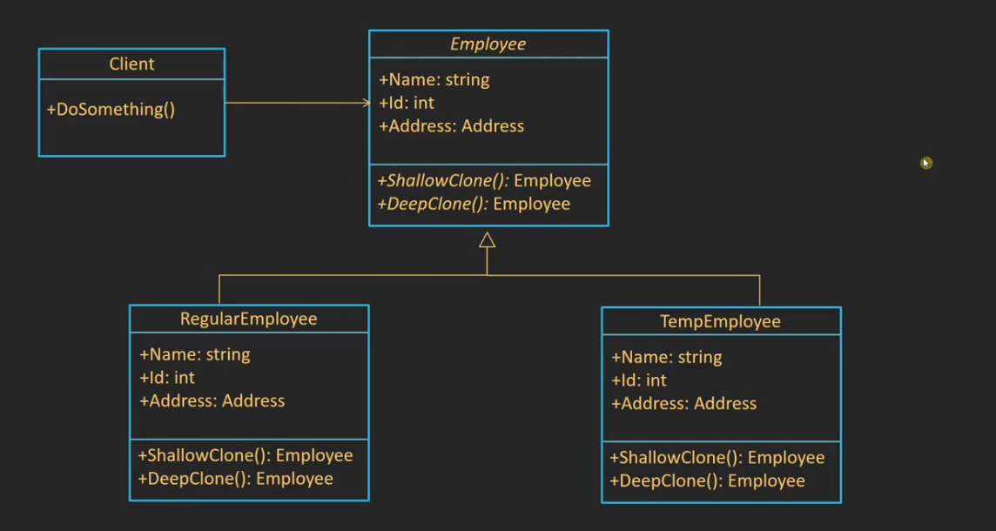

## Shallow copy vs deep copy

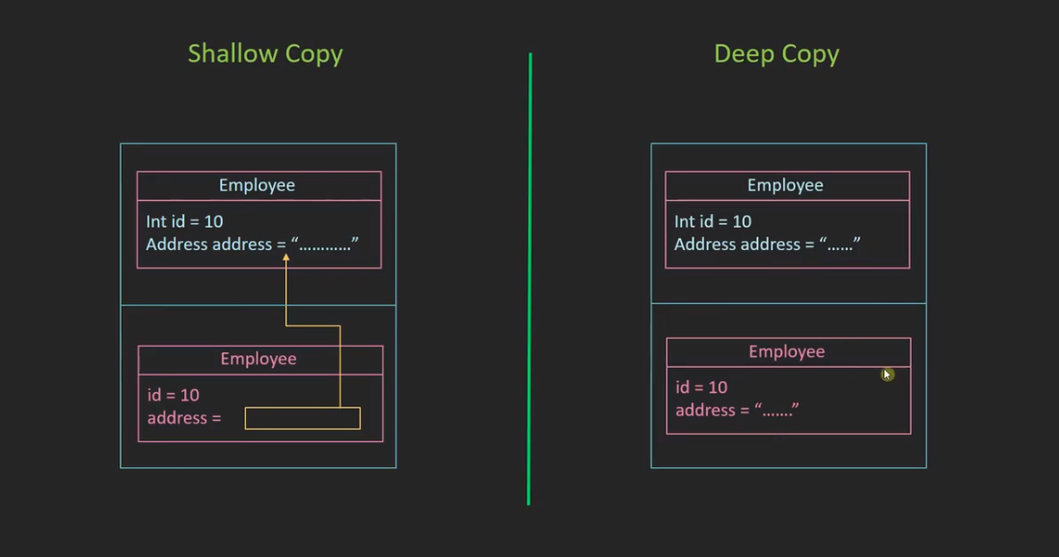

## Builder design pattern

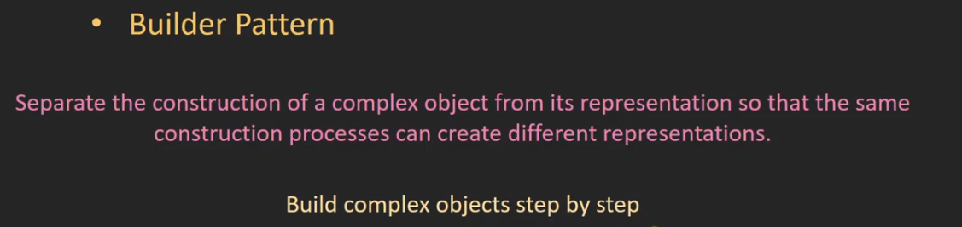

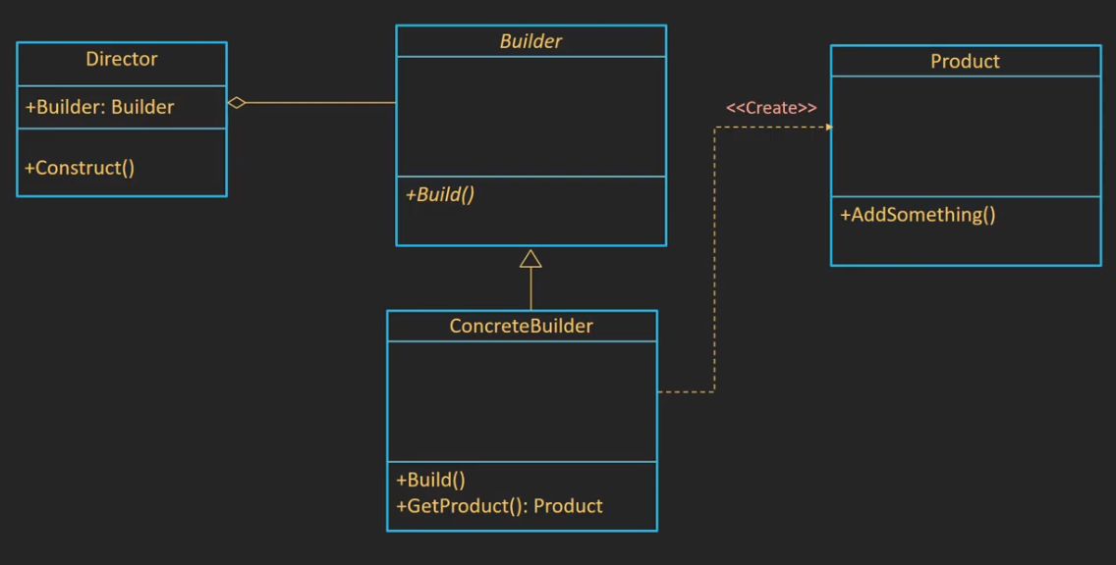

## Factory design pattern

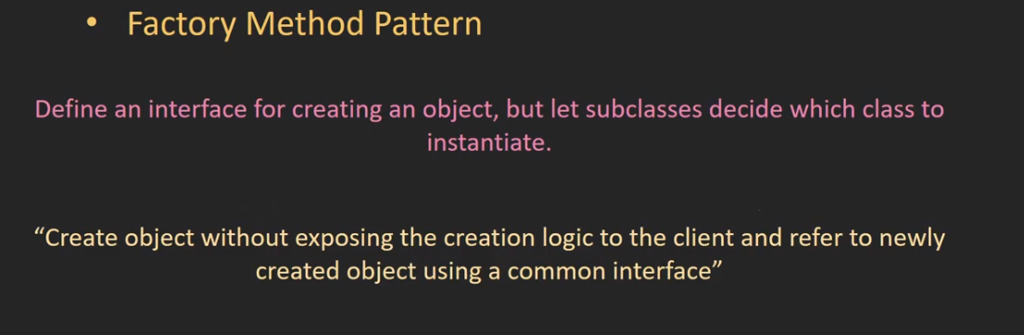

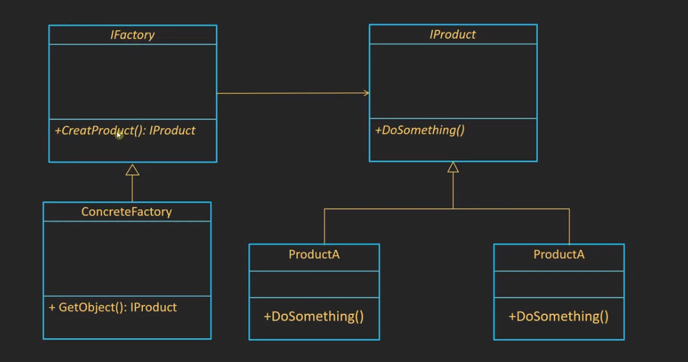

EX

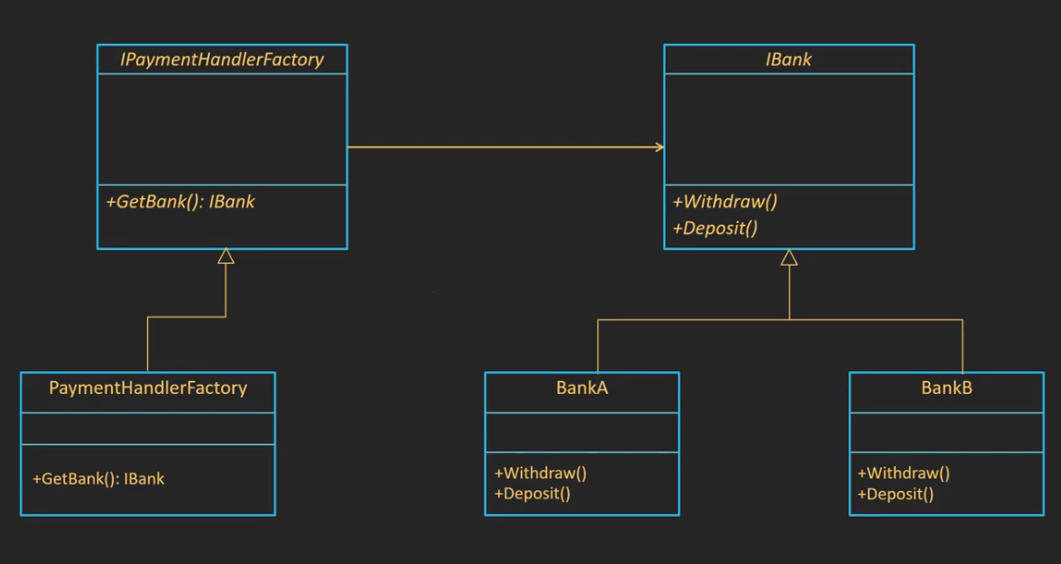

## Abstract Factory design pattern

The factory can create more than interface of obj